 

**Placement Empowerment Program**

***Cloud Computing and DevOps Centre***

**Creating and Configuring a Storage Bucket in Azure Portal**

Name: Subiksha R Department: AML



**Introduction :**

In this task, I created a storage bucket using the Azure Portal, uploaded and downloaded files, and configured access permissions for the bucket. This activity aimed to provide practical experience with cloud storage services, access management, and file operations on Microsoft Azure.

**Overview :**

Azure Storage Accounts provide scalable and secure storage solutions for data objects, such as blobs (binary large objects), files, queues, and tables. In this task, a storage container (bucket) was configured to enable secure data storage and file operations, including file upload and download with appropriate access control mechanisms.

**Objective :**

The objective of this task was to gain hands-on experience with cloud storage operations in Azure Portal. It aimed to provide practical knowledge on creating storage containers, managing file uploads and downloads, and configuring secure access permissions using Shared Access Signatures (SAS).

The task specifically focused on:

* Understanding cloud-based data storage and its applications.
* Learning how to create and configure storage buckets in the Azure Portal.
* Generating and using SAS URLs for secure file access.
* Enhancing skills in managing access permissions for better security.

**Step-by-Step procedure :**

**STEP 1:** Create a Storage Account

* Sign in to the [Azure Portal](https://portal.azure.com/).

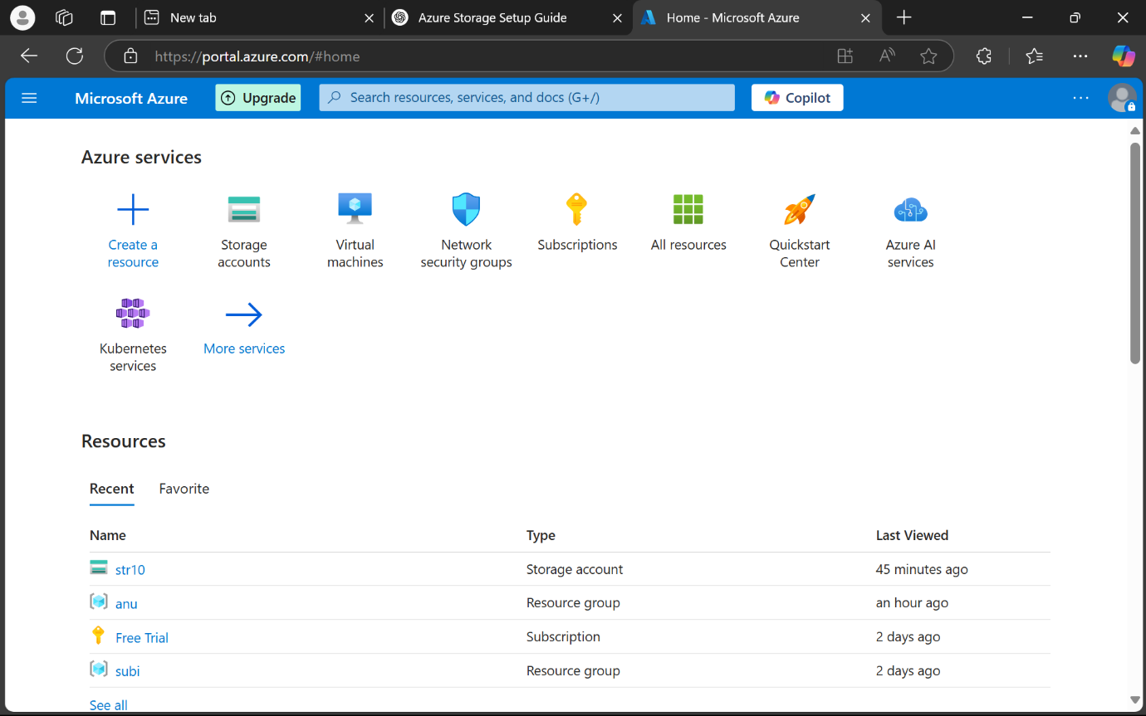

**STEP 2 :**Navigate to Storage accounts from the dashboard.

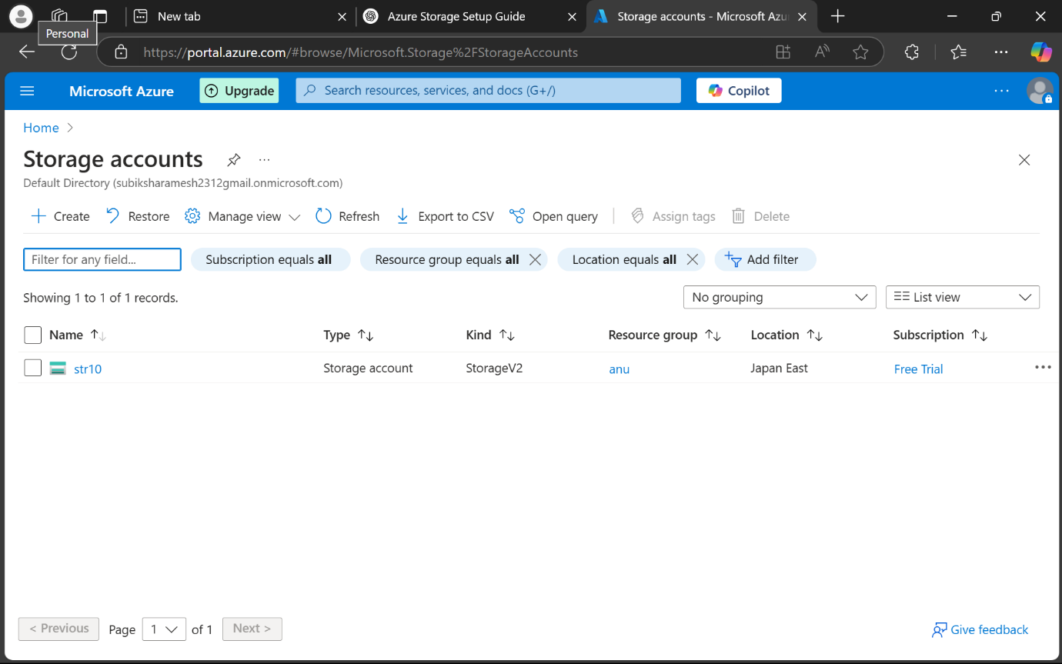

**STEP 3 :** Click Create and provide the required information:

* Subscription: Select your subscription.
* Resource Group: Select or create a new resource group.
* Storage Account Name: Enter a globally unique name.
* Location: Choose a region close to you.
* Performance: Standard (default).
* Redundancy: Locally-redundant storage (LRS).

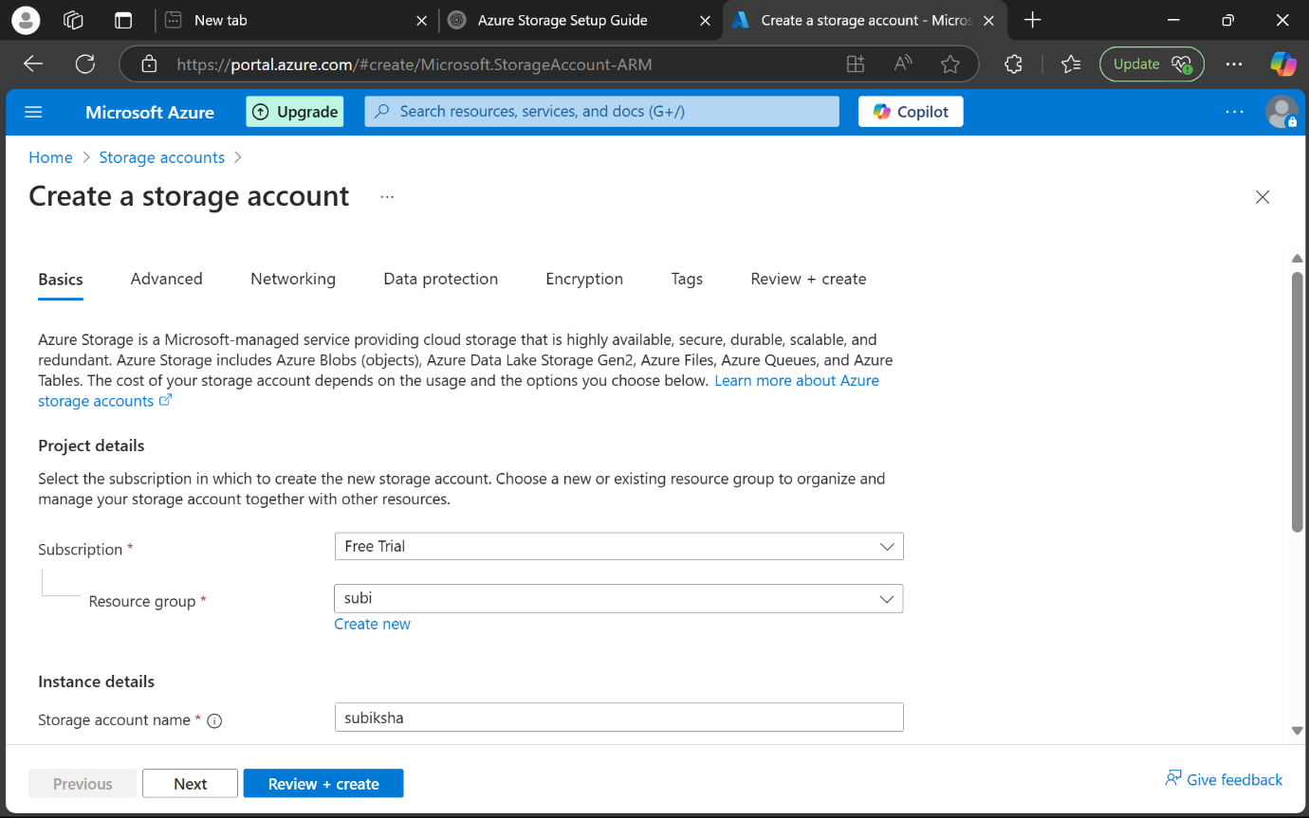

**STEP 4 :** Click Review + Create and then Create.

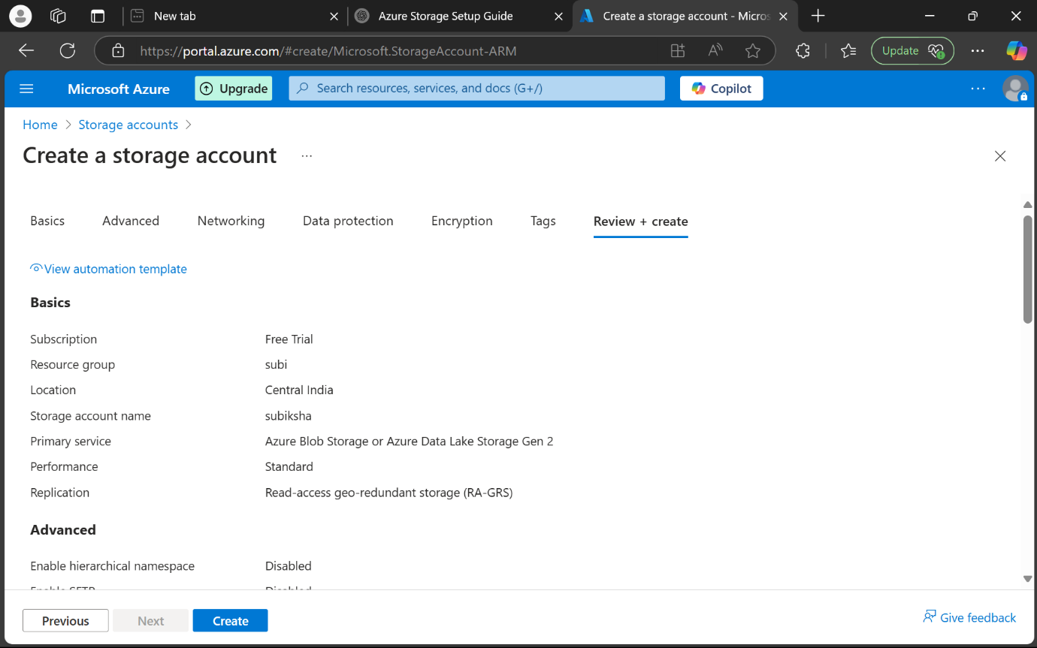

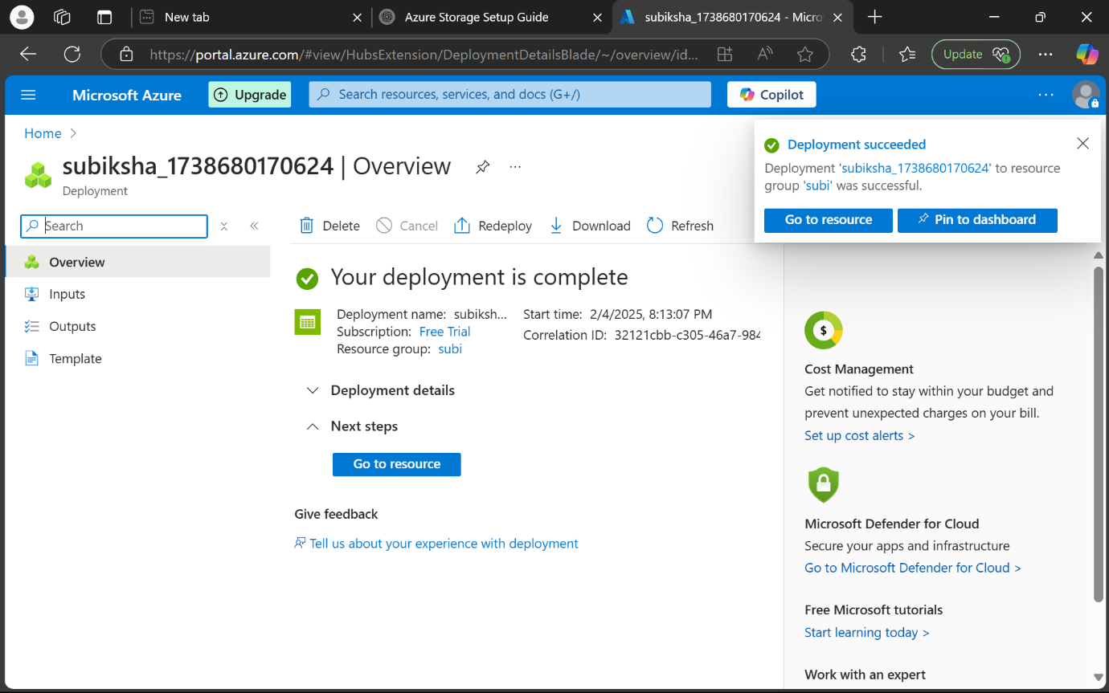

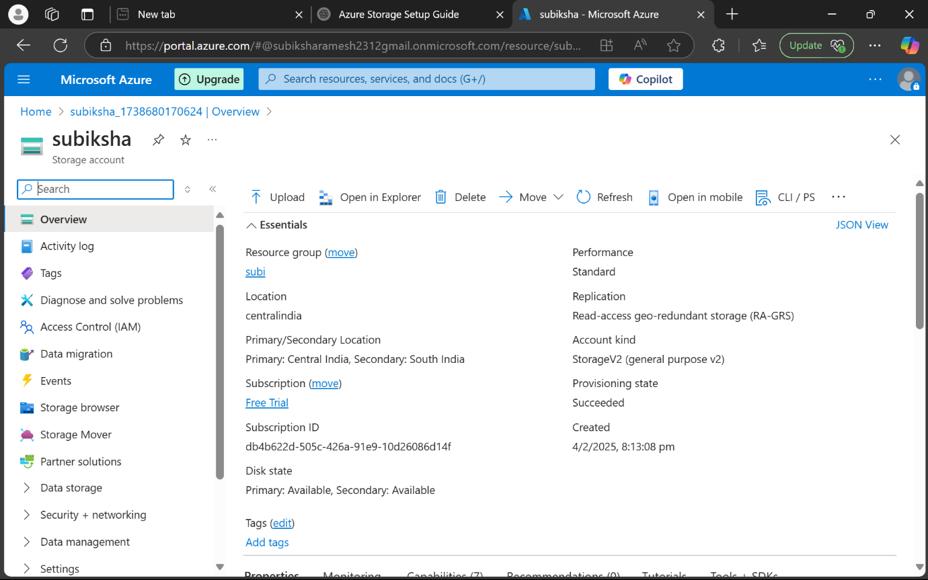

**STEP 5** **:** **Create a Container (Bucket)**

* Open the newly created Storage Account.
* Select Containers under the Data storage section.

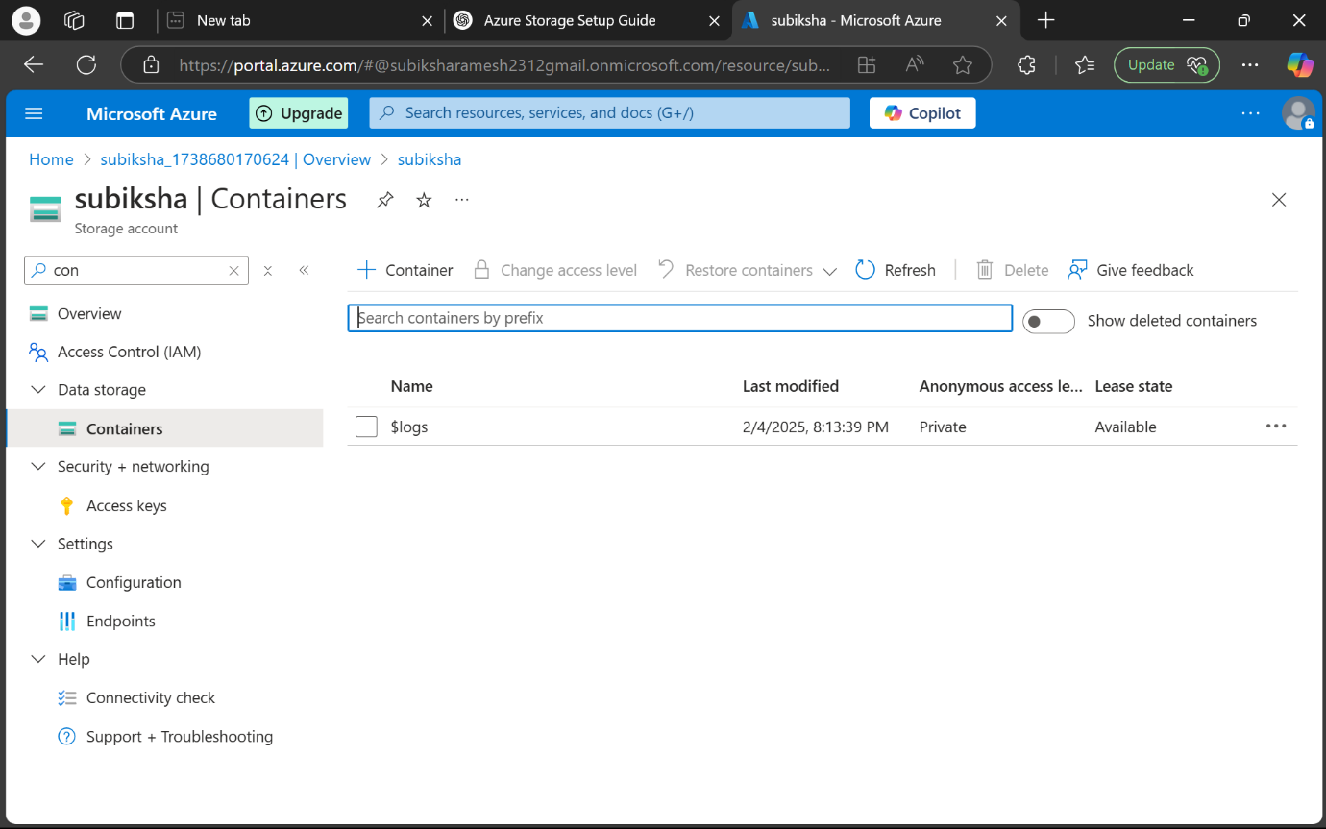

**STEP 6 :** Click + Container, provide a name, and set the Public access level to your desired setting (Private by default).

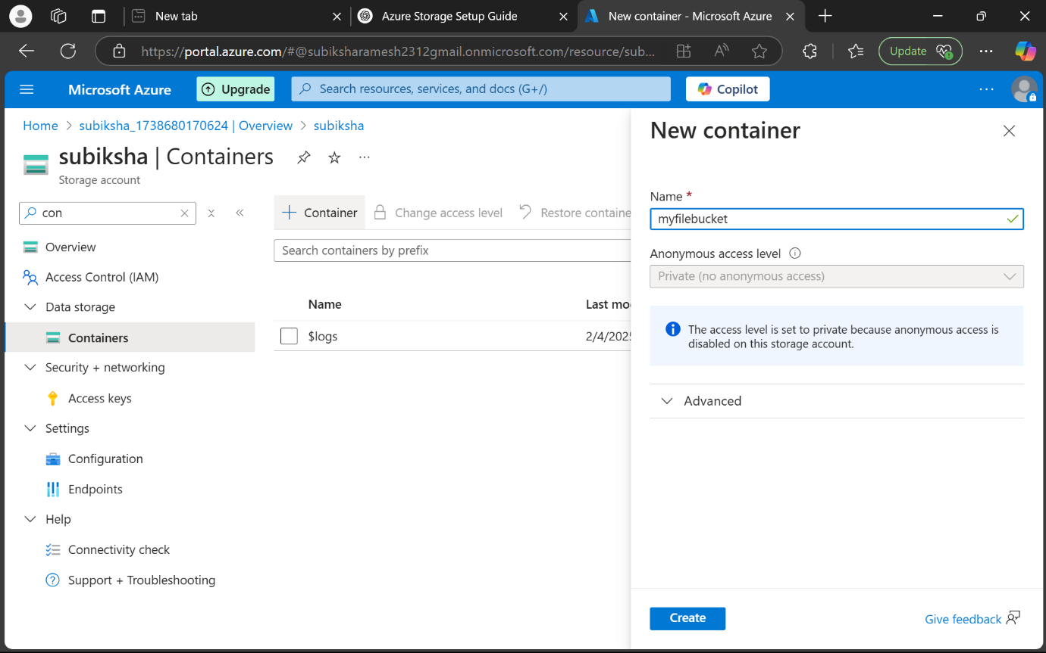

* Click Create.

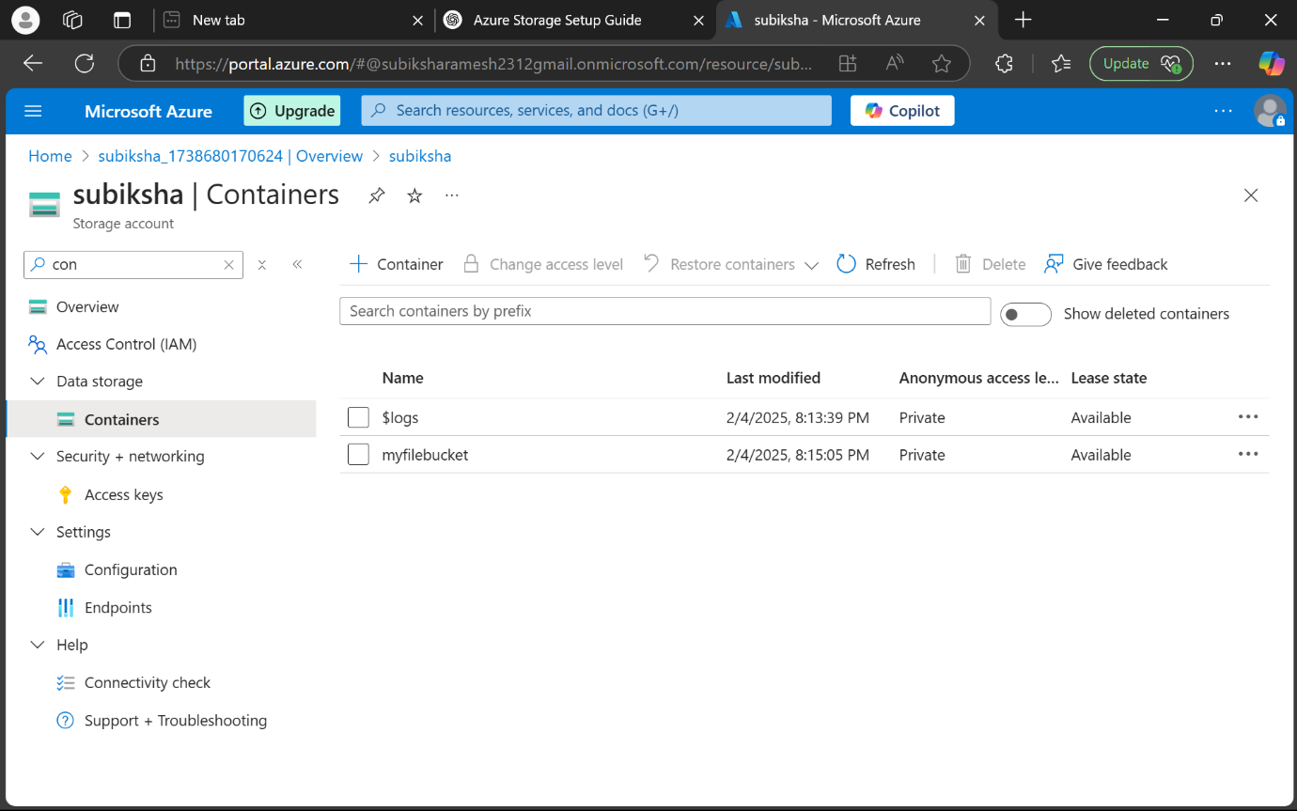

**STEP 7 :**  **Upload a File.**

* Open the created container.

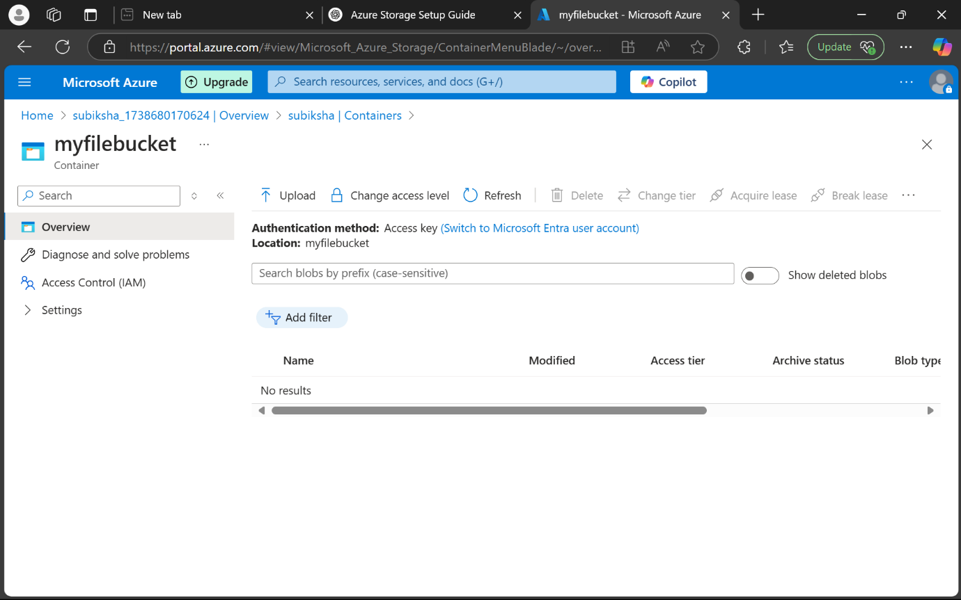

**STEP 8 :** Click Upload and browse to select the file you want to upload.

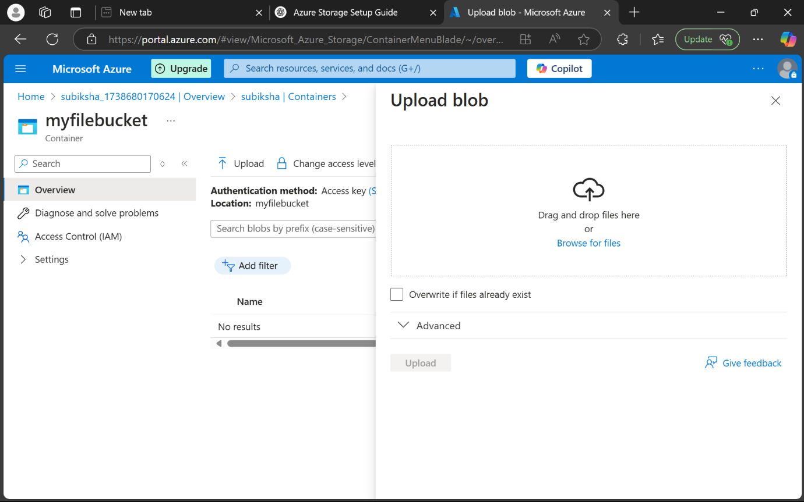

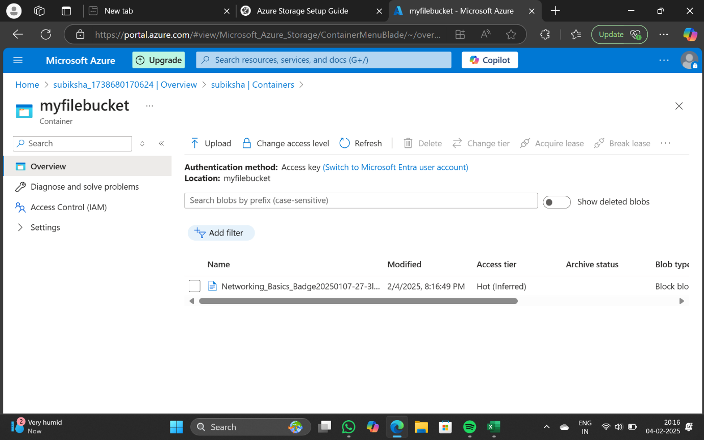

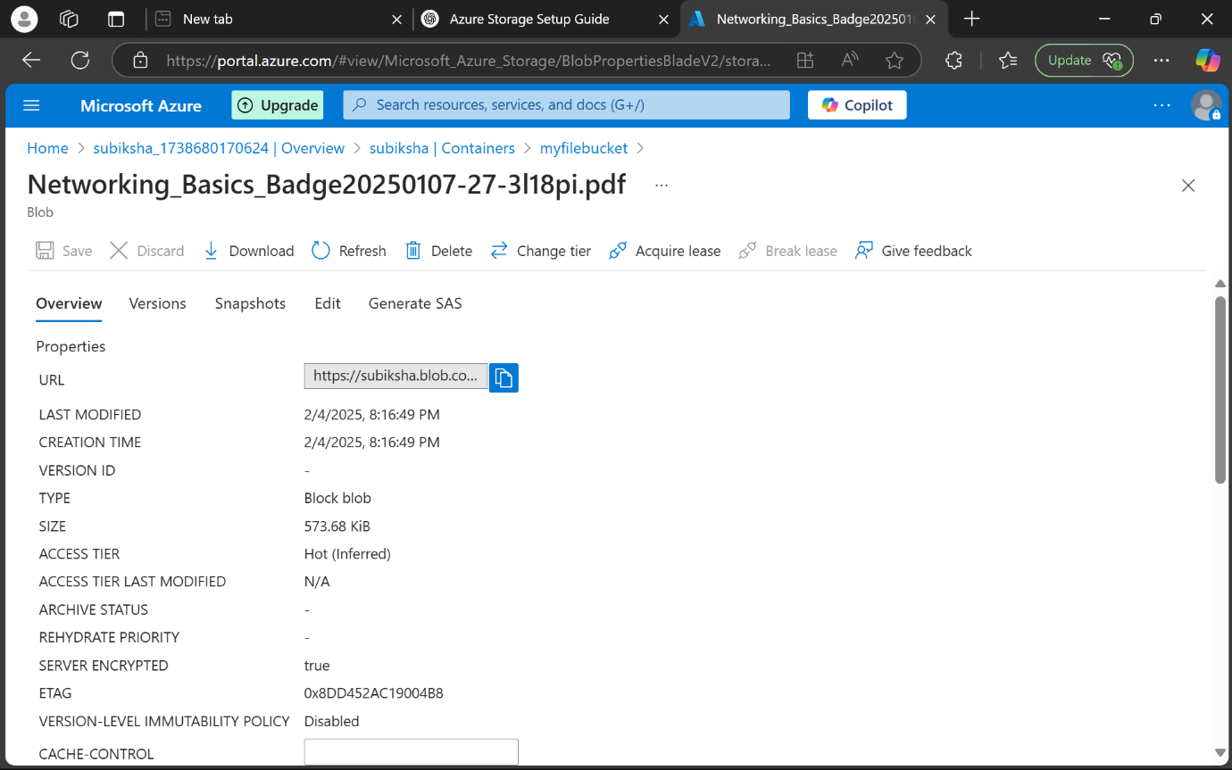

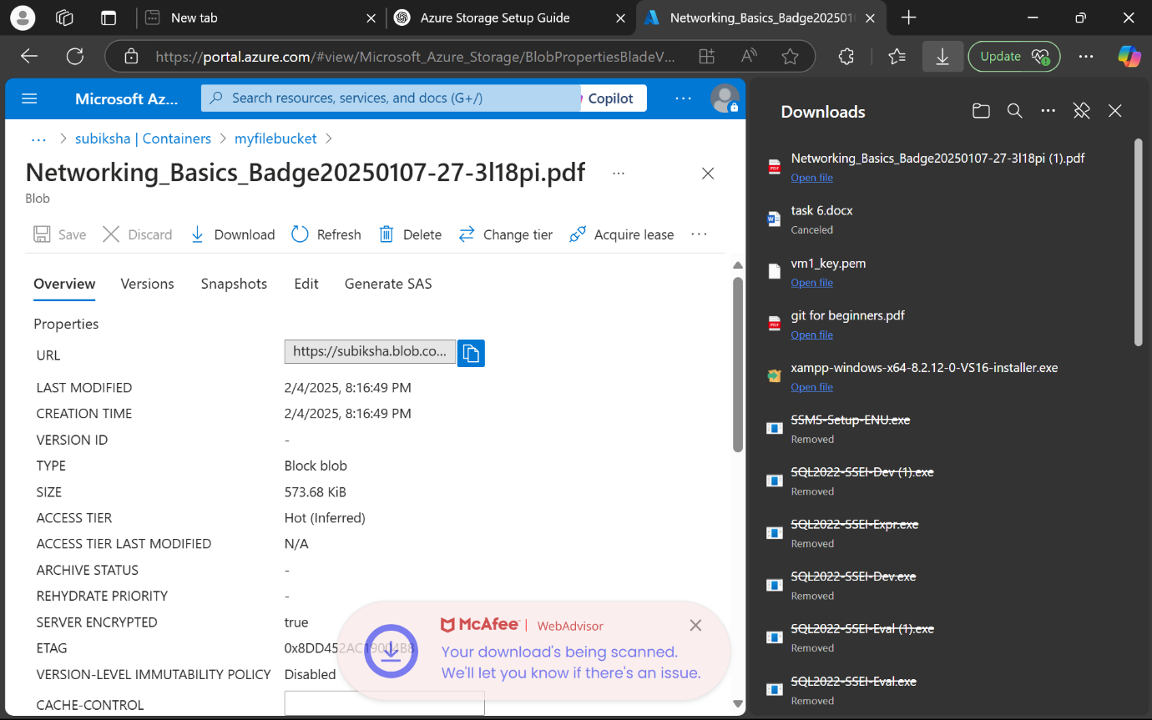

**STEP 9 :** **Generate SAS (Shared Access Signature)**

* Go back to the storage account overview.
* Select Shared Access Signature from the menu.

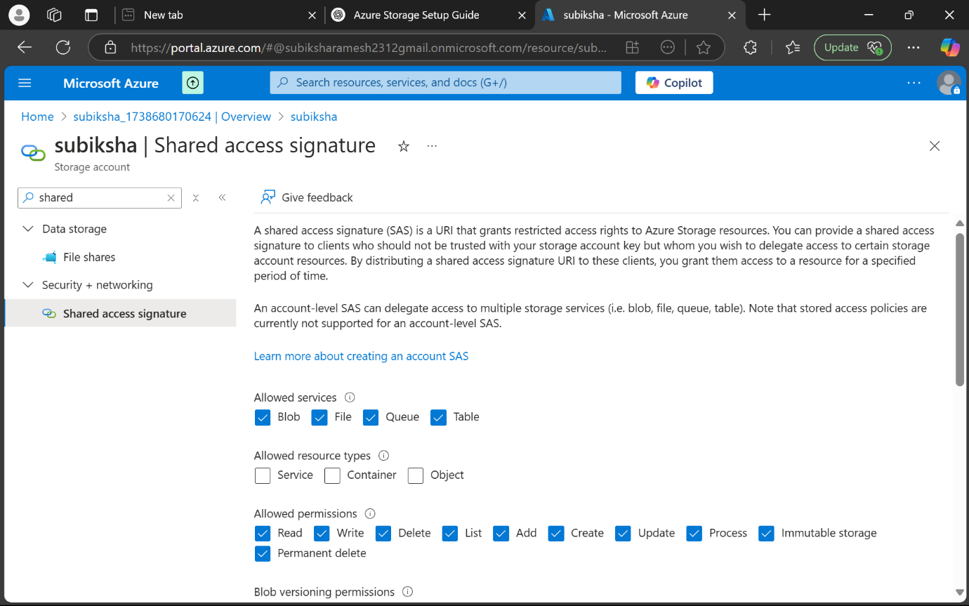

**STEP 10 :** Configure the permissions required (read, write, list, etc.).

* Set the start and expiry times.
* Click Generate SAS and Connection String.
* Copy the Blob SAS URL provided.

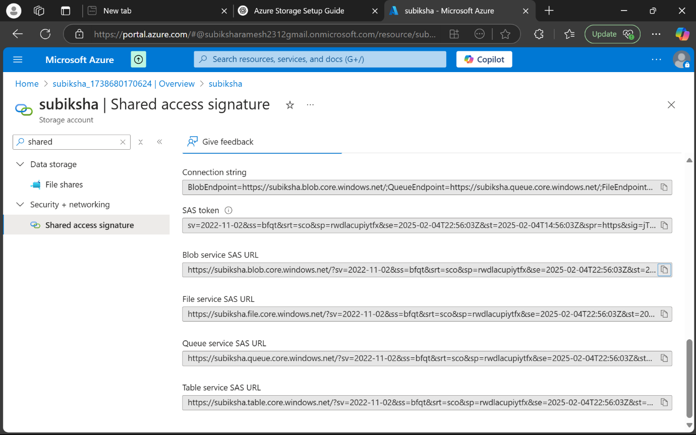

**Outcome :**

The task was successfully completed with the following outcomes:

1. A storage container was created within an Azure Storage Account.
2. Files were successfully uploaded and downloaded using the Azure Portal.
3. Access permissions were configured using SAS tokens, ensuring secure file access.
4. The task demonstrated a clear understanding of cloud storage operations and access management on the Azure platform.